West Virginia University
Robert C. Byrd Health Sciences Center

[name of business]
BUSINESS PLAN
[plan date]

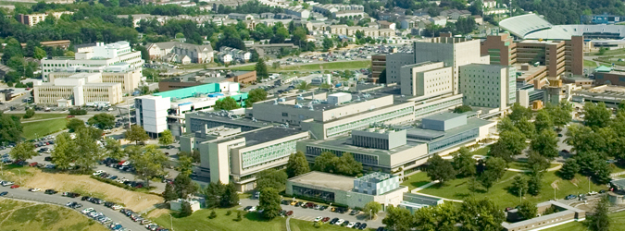

Office of the Chancellor
December 2012

CONTENTS
Executive Summary …………..…………………………..……………………………
Business Overview ………………………………………………………………………
Services …………………………………………………………………………….…………
Market Analysis …………………………………………………………………………..
Marketing Strategy ………………………………………………………………………
Competition ………………………………………………………………………………..
Business Structure & Management ……………………….……………………
Financial Assumptions ……………………………………………………………….
Implementation Timeline …………………..……………………………………..
Appendices ………………………………………………………………………………….

Executive Summary
Write this section last. No more than two pages.
- Overview of the company
- Recap of opportunity
- Brief summary of the market
- Differentiator (what makes us different)
- Description of products and services to be offered
- Senior level management bios
- Key financials

BUSINESS OVERVIEW
- How did we get to this point?
- Why are we entering into this business?
- How did the management team get selected?
- Have we invested our own money? How much to date?
- How is the company legally structured (contract can be in the appendices)
- Do we have external investors and what is their share of ownership?
- Current and future facilities requirements
- Exit strategies

SERVICES
- Describe our services being offered.
- Describe pricing, support, technology etc.
- What are the advantages of using our service and how do they compare to the competition?
- What is the high level timeframe for introducing these services and how do we assure timeline is met?
- Have our services been evaluated by an outside agency for quality?
- Are there plans for expanding our services (or business partnerships) in the future? If so, how?
- Are these new services included in the revenue projections?

MARKET ANALYSIS
- Overall market as well as segment we are targeting
- Market size
- Growth rate
- Our price range (high, average, low)
- Mention any significant changes in the market, short term and long term trends
- External factors that could affect business (i.e. regulations, economy.. etc.)

MARKETING STRATEGY
- Who are our customers?
- How will they use our services?
- How many are there?
- Is this number growing?
- Are there geographical constraints?
- How will we reach our market? (Website, direct advertising etc.)
- How will customers be aware of our company
- Who will be handling sales and marketing – bio

COMPETITION
- Who is our competition?
- What advantage do we have over our competition?
- Why will customers come to us instead of our competitors?
- What are our competitions’ weaknesses? How do we capitalize on these?
- Who is the market leader and why are they in that position?

Organization Structure
- Bio of key management
- Org chart
- Governance (Board of Advisors, etc.)
- Manpower table (positions required)

FINANCIAL ASSUMPTIONS
- How will we finance the business?
- Start-up costs, salaries, fixed overhead
- Financial projections – how much will you need to make to break even, when are you likely to make a profit
- Financial Statements
  - Establishment Costs
  - Financial statements (profit and loss)
  - Cash Flow forecast

IMPLEMENTATION TIMELINE
- Task list with due dates and assignments
- Categorize tasks: start-up, finances, facilities, human resources, information technology, legal

