Simulation Primer

A Basic Introduction

Purpose

The purpose of this Primer is to provide an introduction to the area of “Medical Simulation” for Physicians and other health care personnel.

Introduction

It has become very popular to utilize advanced technologies in the educational environment. These technologies include medical simulation, web based information systems, interactive CD-ROM technologies and Telehealth communication. When considering using an educational technology it is necessary for the instructor to consider what benefits will be gained. Use of the technology must provide:

- Enhanced information transfer
- Enhanced student performance
- Enhanced student reasoning
- Enhanced creativity
- Cost efficiency.

Simulation technologies are particularly “in vogue”. When considering implementing a medical simulation program the instructor must know what simulation modalities are available. A popular system for categorizing simulation has utilized the word fidelity. Simulators have been described as having high, medium or low fidelity. High fidelity should mean that the simulator very accurately depicts the “real world” task. Low fidelity implies that the task is poorly recreated by the simulator. Unfortunately, in the literature high fidelity has come to mean the use of technologically advanced equipment such as computers whereas low fidelity is used to describe simple simulations. An example of this confusion is presented on page 4. The Department of Defense developed a more useful characterization schema:

- Training Aids
- Partial Task Simulation
- Standardized Patient Simulation
- Mannequin Based Simulations
- Screen-Based Simulation
- Virtual Reality Simulation

Simulation sub categories
- Passive – doesn’t do anything
- Active – Does something
- Interactive - Does something in response to the student.

Training Aids

Training aids are any adjunct used for simple demonstration and/or beginning task familiarization. A bare mannequin or skeleton would be an example of this category. Other examples would include models of various anatomic parts such as the larynx or liver. Every simulation center must have many pieces of medical equipment such as the pleurovac, foley catheter or intravenous catheters for the creation of simulations.

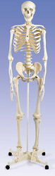

Partial Task Simulators

Partial tasks simulators are more complicated devices, perhaps with a computer, that are used to teach a partial task. Examples would include:

- Intubation heads
- Chest tube insertion mannequins
- Box trainers
- IV insertion
- Foley catheter insertion
- Nasogastric tube insertion models
- Hysteroscopy
- TURP
- Eye examination
- Ear examination

The aircraft simulator has become quite familiar to the public. These are “million dollar” sophisticated, simulators used to realistically train aircraft pilots. The airline industry also uses a partial task simulator referred to as a crew trainer. This is a simple simulator which does nothing except teach the learner where the instruments and flight controls are. This trainer does not simulate flying but simply the cockpit. This is why it would be referred to as a partial task simulator.

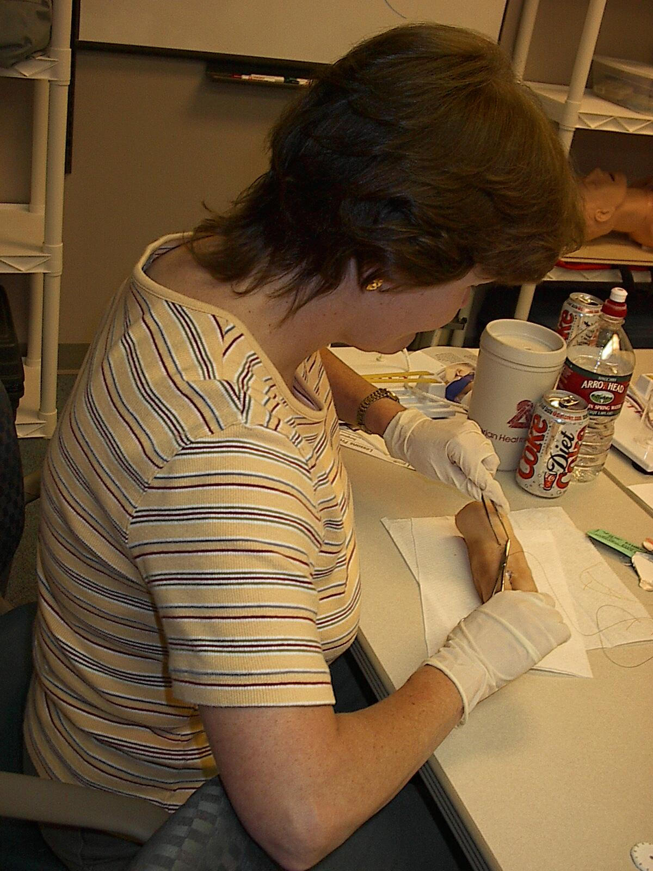

Above you see a medical student learning how to suture on a simulator, a pig’s foot. If we have thirty medical students who need to learn how to suture, we use this simple inexpensive simulator. If we only have three medical students on a rotation who need to learn how to suture we can use “suture tutor”. This is a simulator which is computer assisted. The student uses a computer which instructs them to open a box which contains synthetic skin and all of the suturing materials. The student is instructed by the computer. If one has 30 students, one can afford the cost of an instructor along with a simple and inexpensive simulator. If one only has three students it is better to use a more expensive simulator which does not require an instructor.

Some people would refer to the pig’s foot as a low fidelity simulator and the suture tutor as a mid fidelity simulator. This is not the case. The pig’s foot recreates the real situation more accurately than the synthetic skin. The confusion is brought about by the simplicity of the simulation and the fact that no computer is used.

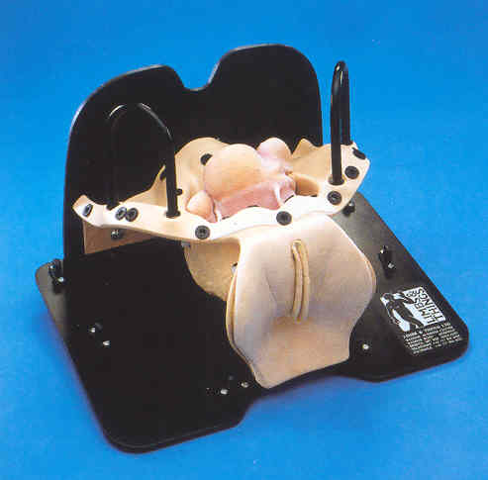

Above we see another example of a partial task trainer. This is a pelvic exam model manufactured by Limbs and Things. The skin feels extremely realistic. One is able to choose various simulated internal organs to recreate pathology. When using this model, we like to allow the students to examine the model with out any skin overlaying. This allows them to conduct a bimanual exam and to know exactly what they are touching. We can place skin over the model and use a variation manufactured by METI where pressure sensors have been placed with in the model which allow the instructor to see exactly where the student is touching and how much pressure they are applying. In this instance we have taken a high fidelity partial task trainer and by using computer technology enhanced the educational effectiveness.

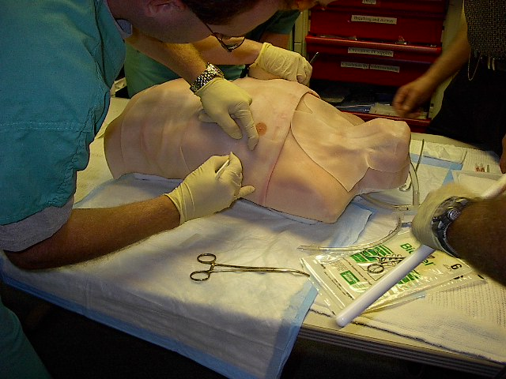

Above we see a partial task train which is named “trauma man” which is manufactured by Simulab. This simulator is used to teach students how to insert chest tubes and to perform a cricothyrotomy. The College of Surgeons accepts this simulator as an acceptable alternative for the Advanced Trauma Life Support Course. Below is a useful simulator for teaching ear examinations particularly useful for medical students.
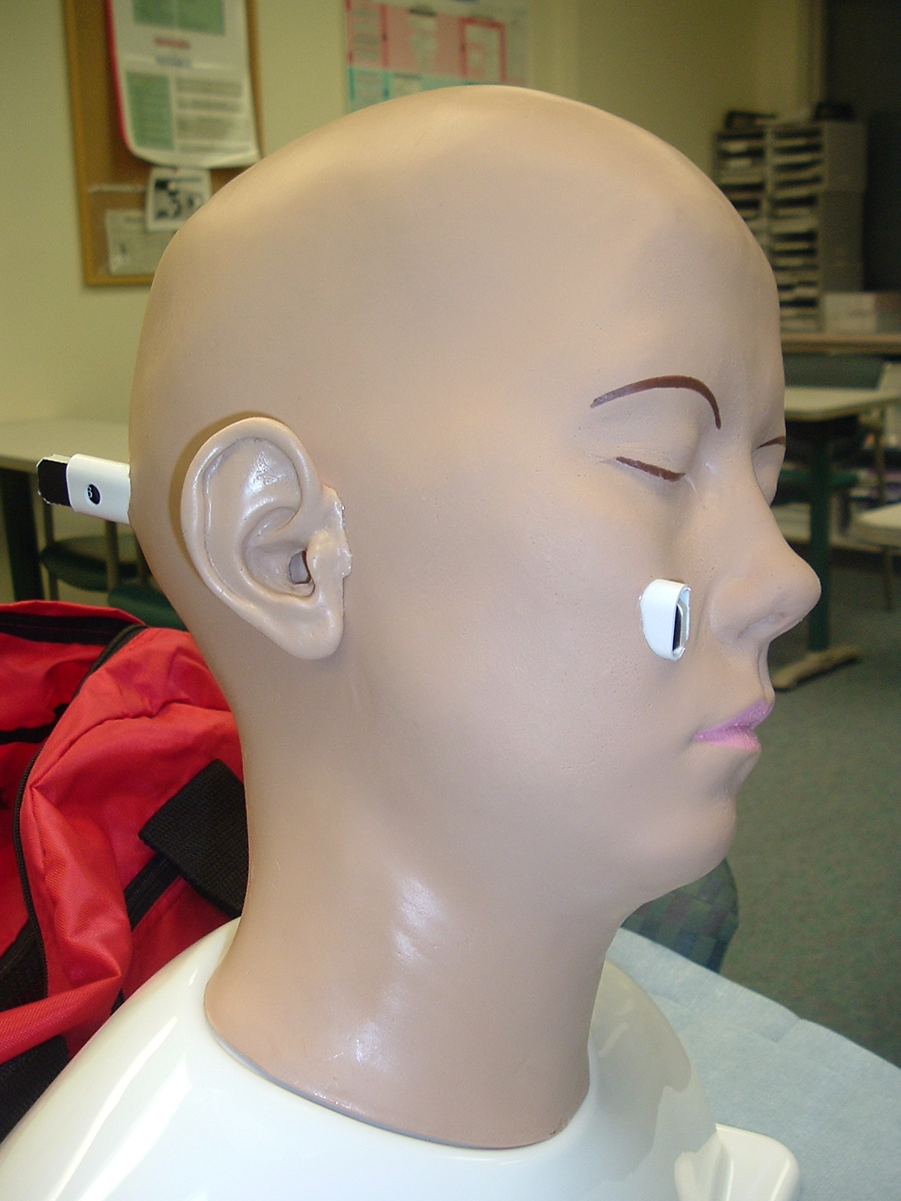
Virtual Reality

Many procedures in modern medicine utilize scopes attached to CRT screens. Examples would include bronchoscopy and laparoscopy. These are very rich application areas for the development of simulators. Below you see an example of a broncoscopy simulator and a laparoscopy simulator.

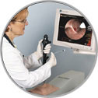

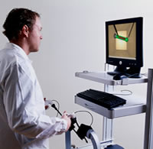

The above two pictured simulators would be examples of virtual reality simulators. Virtual reality simulators can be classed into three groups:

- Flat screen: computer based training and games
- Augmented: flat screen with an interactive peripheral such as surgical instruments
- Immersive: visual immersion with a 360° view either with goggles for helmets or directly projected on the eye.

The laparoscopic trainer which is pictured would be an augmented, virtual reality, partial task trainer. This particular instrument is the Minimally Invasive Surgical Trainer (MIST).

Partial task trainers such as these laparoscopy instruments are only useful if they incorporate educational methodology into the program to achieve educational objectives. It is not good enough for these machines to simply recreate a single specific environment where the task is normally performed. The MIST simulator was developed by determining the specific skills needed by a laparoscopist. Exercises to teach the skills were developed in geometric environments. In order to be worthwhile the computer program must:

- introduce the learner to the rationale behind the exercise
- show the learner how to do the exercise correctly and demonstrate errors
- give the learner the opportunity to practice the exercise at various levels of difficulty
- gather metrics on the performance of the learner in order to provide formative and summative feedback.

Mannequin Simulators

Mannequins have been used as partial task trainers in many circumstances. The most famous example would be the “ResuciAnni“. This mannequin is used for training in cardiopulmonary resuscitation. A mannequin based “full” simulator, in the medical context, needs to include pharmacologic and physiologic models. An example of this type of mannequin is the METI “Human Patient Simulator (HPS).

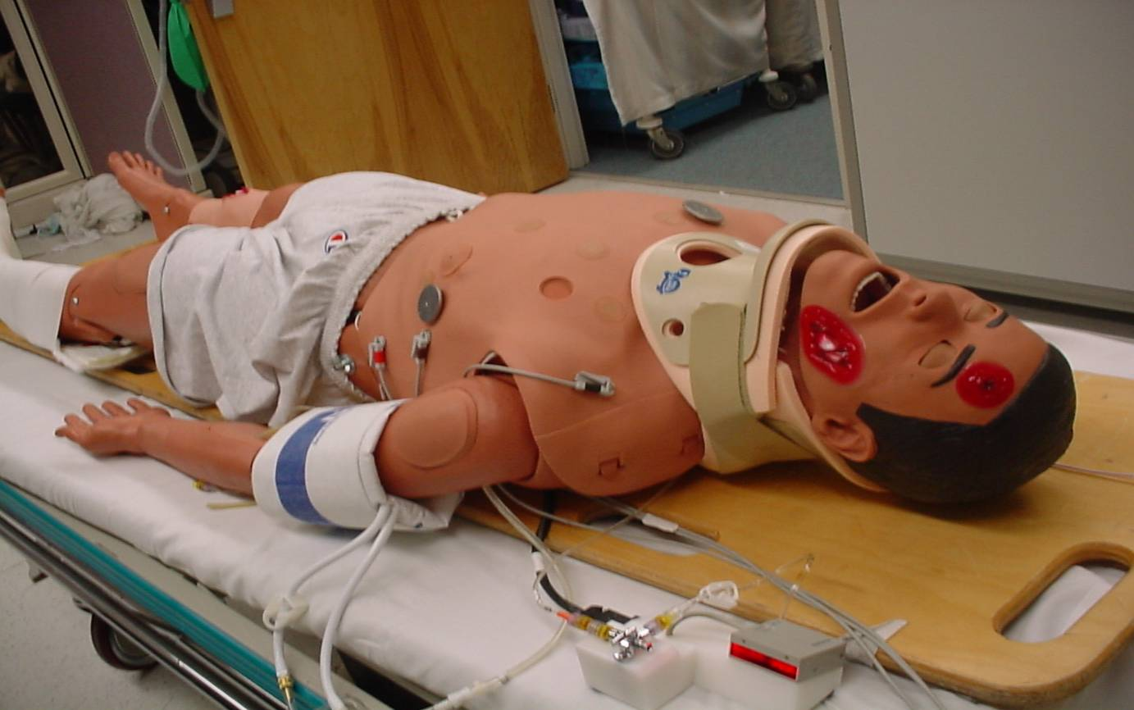

This simulator has:
- eyes that open and close,
- pupils which react to light
- an active airway
- pulses, breath and heart sounds
- but most importantly lungs that actually respire; meaning that they breath in gas mixtures, extract oxygen and exhale carbon dioxide
- pharmacologic and physiologic modeling.

The ultimate “full patient simulator” would be the “Standardized Patient” which is a trained actor who simulates medical situations for a student to be introduced to.

Simulation Systems

Mannequins and partial tasks simulators can be integrated to operate together in simulation systems. An example would be a human patient simulation laboratory which utilizes an HPS mannequin, anesthesia machine or ventilator, defibrillators and numerous training aids. Below we see a picture of a simple simulation system.

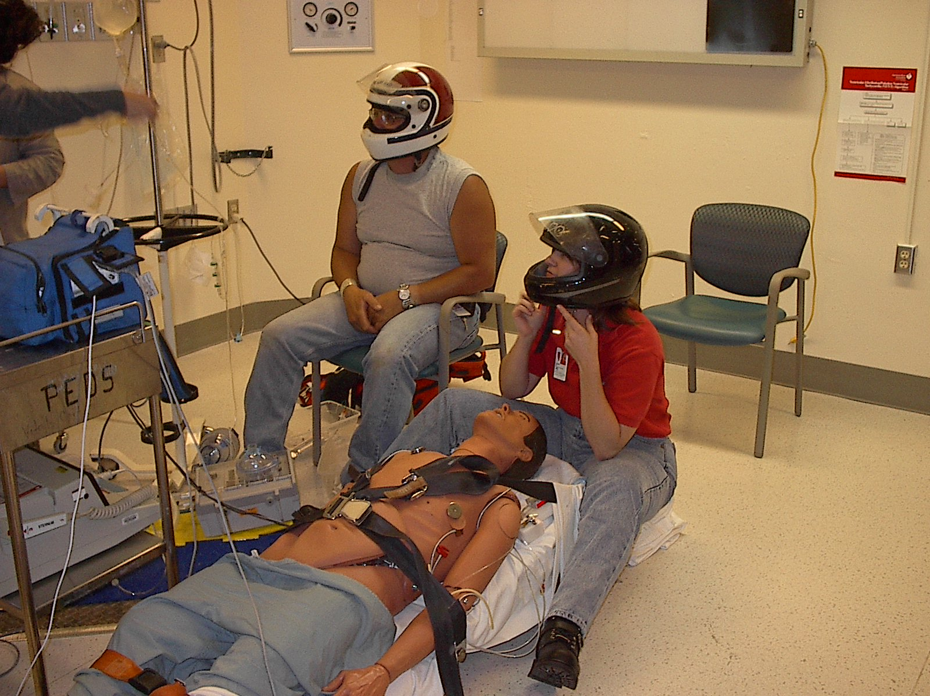

Simulation systems can be improvised. Below we see an improvised system using a simple partial task training baby mannequin and a tin foil warming hood.

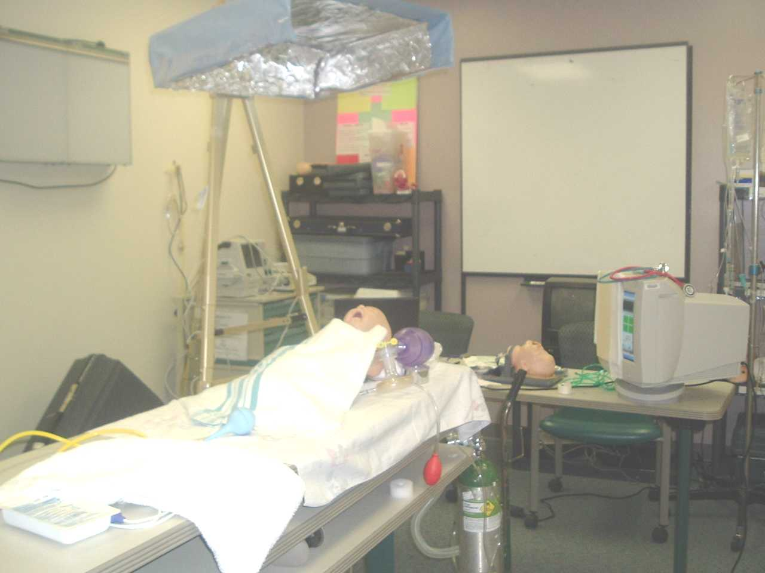

The ultimate simulation environment would be a “Cave”. The following illustration shows the components of the “Cave”.

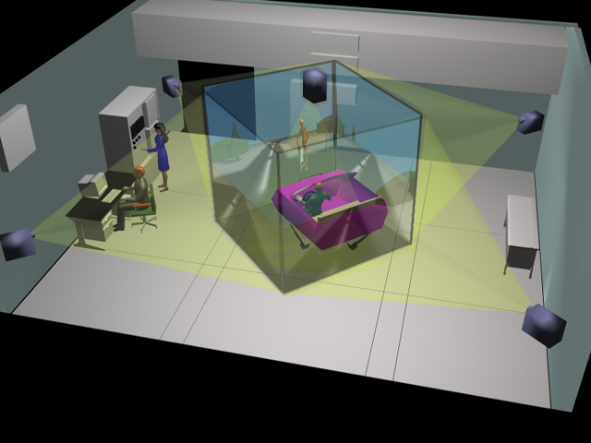

The walls, ceiling and even floor of the cave are composed of rear projection screens. It is possible to create an environment through the computer controlled images projected. . Other props and simulators are utilized with the goal of teaching students how to deal with a difficult environment. Due to expense, there are few caves in existence.

